On Demand Training Registration and Requirements

To register for the On Demand training, click the link at the bottom of the page.

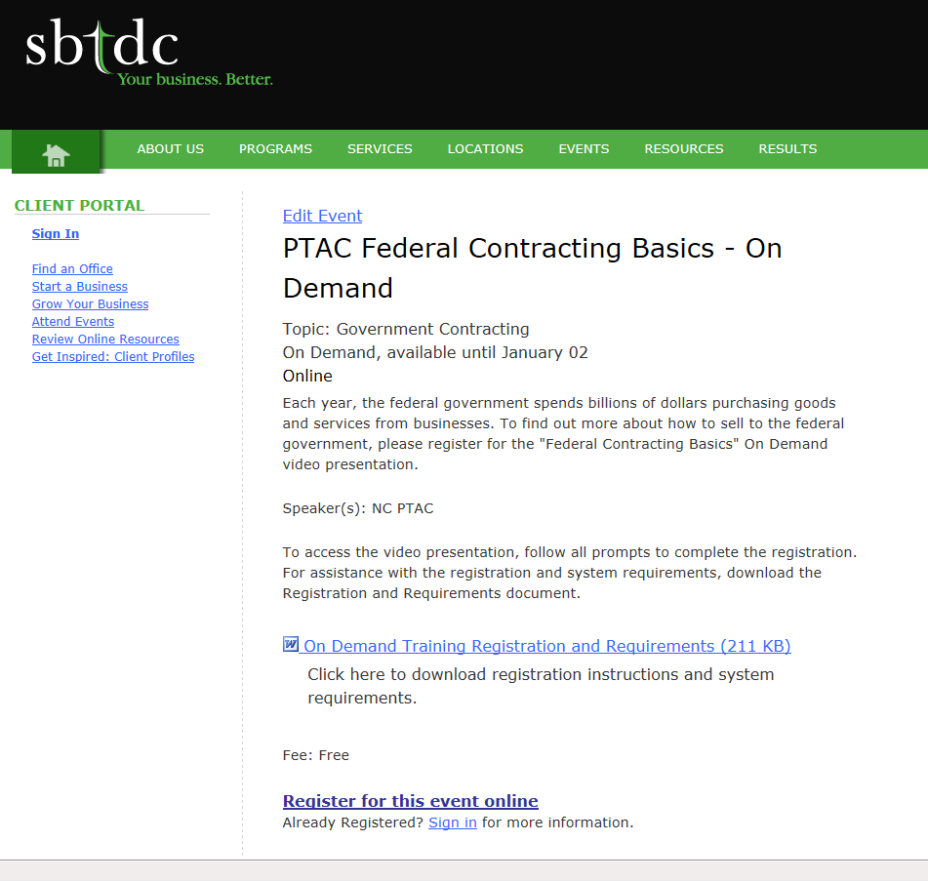

On the registration screen, enter your email address and click Continue.

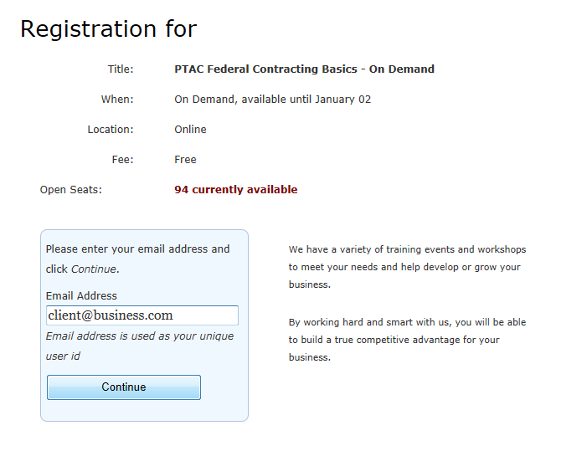

If you are a new SBTDC client, you will be prompted to create a client profile for your existing or planned business. The profile will include business contact information, size information, and demographics. If you are an existing client, you will be prompted to log in to your client dashboard. If you have a password, you will be prompted to enter the password to log-in. If you do not have a password or you are unsure of your password, you can send a ticket and a ticket code will be emailed to you. This code will allow you to log-in to your dashboard.

Once you have created a profile or logged into your dashboard, you will be routed to a confirmation page. Click Register to confirm your registration for the On Demand training.

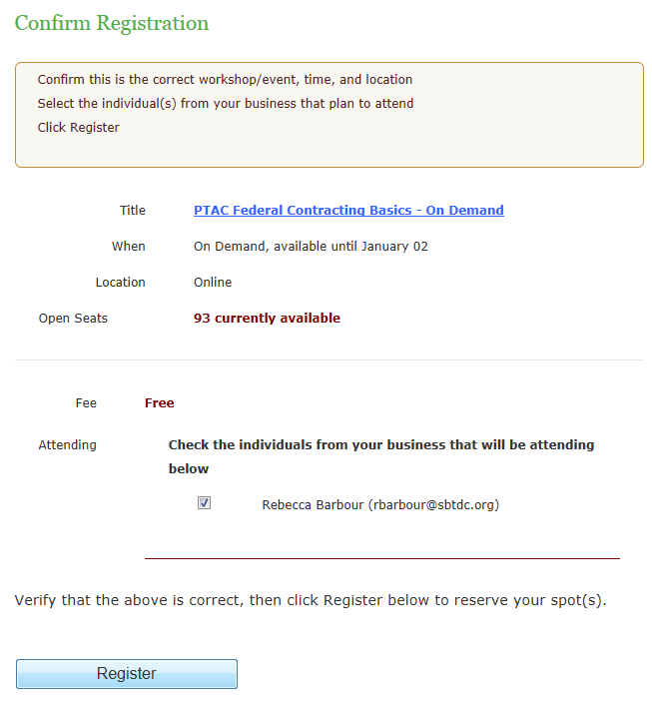

Once you have confirmed your registration, click continue to access your dashboard and the On Demand training.

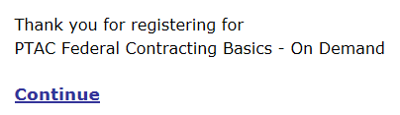

Your client dashboard will display any training events that you have registered for. Click on the appropriate link to access the video presentation and presentation slides for the On Demand training.
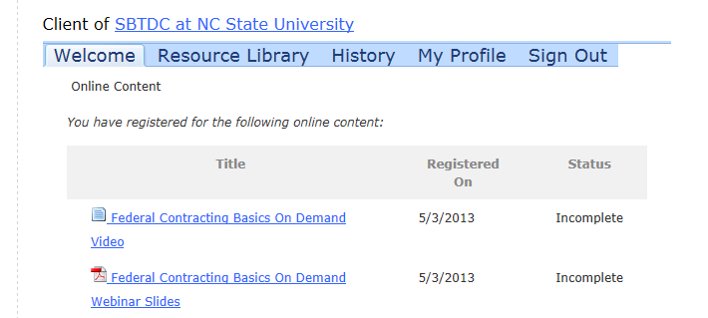

If prompted, click “Show all Content” to access the video.

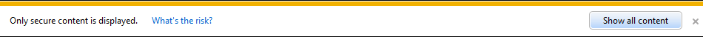

Once the video has loaded, click the play button to access the video.

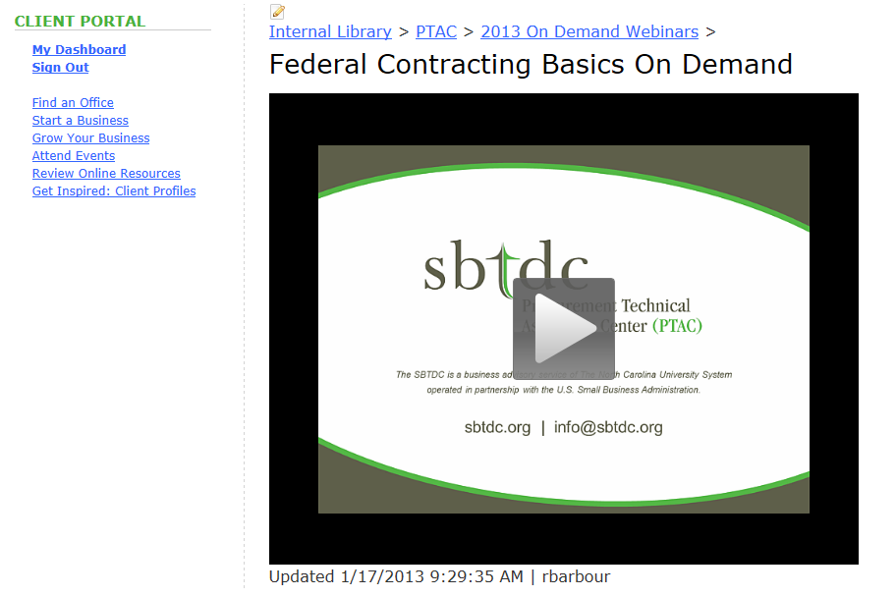

You will also receive a confirmation email confirming your registration. You may access the On Demand training at any time by clicking the links contained in the email or by logging into your client dashboard.

